This analysis covers the 10 Federal Energy Regulatory Commission (FERC) Regions. The FERC Regions encompass the contiguous U.S. and consist of seven independent system operators (ISOs)/regional transmission organizations (RTOs) and three non- ISO/RTO FERC Regions. The ISO/RTO FERC Regions are ISO New England (ISONE), New York ISO (NYISO), PJM Interconnection (PJM), Midwest Independent Transmission System Operator (MISO), South- west Power Pool (SPP), Electric Reliability Council of Texas (ERCOT), and California ISO (CAISO). The non-ISO/RTO FERC Regions are Northwest (NW), Southwest (SW), and Southeast (SE). For this analysis, a modified ‘‘All CA’’ FERC Region, consisting of CAISO plus all non-ISO entities within California, was used. Fig. 1 shows a map of the FERC Regions.

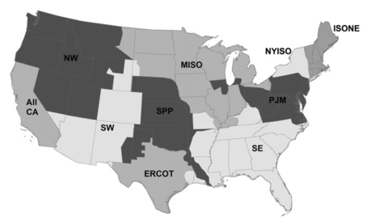

https://www.ferc.gov/industries/electric/indus-act/rto.asp

Fig. 1. Federal Energy Regulatory Commission (FERC) Regions.

Hourly electric load data were collected for each FERC Region for 2006 and 2007. Load data were gathered from the ISO/RTO websites for ERCOT (Electric Reliability Council of Texas, 2005– 2007), SPP (Southwest Power Pool, 2000–2007), MISO (Midwest ISO, 2005–2006, 2006–2007), PJM (PJM Interconnection, 2005– 2007), NYISO (New York ISO, 2005–2007), and ISONE (ISO New England, 2005–2007). Load data for All CA, NW, SW, and SE were obtained from FERC’s Form 714 Submission and Viewer soft- wares, (Federal Energy Regulatory Commission, 2006–2007). Hourly data were converted to Greenwich Mean Time (GMT). For reference, GMT is 5 h ahead of Eastern Standard Time.

ERCOT data source

Link: <http://www.ercot.com/gridinfo/load/load_hist>

Time: 2002 – 2016

SPP

Link: <https://marketplace.spp.org/pages/hourly-load#%2F2016>

Time: 2011 - 2016